A PROJECT REPORT ON

**GROCERY MANAGEMENT SYSTEM**

SUBMITTED TO

THE UNIVERSITY OF PUNE

**IN PARTIAL FULFILMENT OF THE REQUIRMENT**

**FOR T.Y.B.Sc (COMPUTER SCI.) SEMESTER IV.**

SUBMITTED BY:

**SHAIKH MUSKAN NASHIR (6603)**

**SUBEDI RAHUL RAJENDRA (6622)**

**SHAIKH DILNAWAZ IFTEKHAR (6602)**

UNDER THE GUIDANCE OF

**Dr .Mahtab Alam**

**Mr. Mohammed Abdul Quddus**

DEPARTMENT OF COMPUTER SCIENCE

AKI’S

POONA COLLEGE OF ARTS SCIENCE & COMMERCE

CAMP, PUNE

[2018-19]

**INDEX**

|  |  |  |
| --- | --- | --- |
| **Sr.no** | **Topic** | **Pageno** |
| 1. | Introduction | 3 |
| 2. | Project Description | 4-11 |
| 2.1 | Problem Definition | 4 |
| 2.2 | Existing System | 5 |
| 2.3 | Propose System | 6 |
| 2.4 | Feasibility Study | 7-8 |
| 2.5 | Need and Scope of System | 9 |
| 2.6 | Objective of the System | 10 |
| 2.7 | Hardware and Software requirement | 11 |
| 3 | UML Diagram | 12-26 |
| 3.1 | Class Diagram | 12 |
| 3.2 | Object Diagram | 13 |
| 3.3 | Use case Diagram | 14 |
| 3.4 | Sequence Diagram | 15-17 |
| 3.5 | Activity Diagram | 18 |
| 3.6 | State Transition Diagram | 19-21 |
| 3.7 | Collaboration Diagram | 22-24 |
| 3.8 | Component Diagram | 25 |
| 3.9 | Deployment Diagram | 26 |
| 4. | Data Dictionary | 27-28 |
| 5. | Test Case Design | 29-31 |
| 6. | I/O Screen | 32-51 |
| 7. | Report | 52-54 |
| 8. | Limitation of the System | 55 |
| 9. | Future Enhancement | 56 |
| 10. | Conclusion | 57 |
| 11. | Bibliography | 58 |

**INTRODUCTION**

* A Grocery store is a retail stored that primarily sells food.
* A Grocer is a bulk seller of food.
* As pollution around the word has increased buying food on the road side is not advisable.
* Whether is charge of a sum
* All individually owned grocery stored or one that is part of larger chain maintaining a grocery stored successfully involve considerable responsibility.
* There are a lot of successful websites such as BigBasket.com, askmegrocery.com etc. in this space.
* Purpose of Online Grocery Management system is to allow customer to shop virtually using internet.
* Computerization of online store will increase the ease, efficiency and reduce the chances of manual errors.

.

**Problem Definition**

We are going to build a software restaurant automation system that will have several features such as:

* Stock management
* Internet online reservation
* Online ordering via network enabled handheld computer
* Customer management
* Accounting
* Executive information system

In addition to those features, we are planning to add

* Statistical data about sales using graphics
* Customer profile (customer name, address, preferences, etc.)

**EXISTING SYSTEM**

In the existing system the exam are done manually but in proposed system we have to computerize the exam using this application.

**LIMITATION OF EXISTING SYSTEM:**

* Lack of security of data.
* More man power.
* Time consuming.
* Consumes large volume of paper work.
* Needs manual calculations.
* No direct role for the higher officials.
* To overcome all these limitations the system needs to be computerized.

**PROPOSED SYSTEM**

The aim of purposed system is to develop a system of improved facilities. The proposed system can overcome all the limitations of the existing system. The system provides proper security and reduces the manual work.

**FEASIBILITY STUDY**

After doing the project Online Grocery Management System, study and analysing all the existing or required functionalities of the system, the next task is to do the feasibility study for the project. All projects are feasible given unlimited resources and infinite time.

Feasibility study includes consideration of all the possible way to provide a solution to the given problem. The Proposed solution should satisfy the entire user requirement and should be flexible enough so that future change can be easily done based on the future upcoming requirement.

**1: Economical Feasibility**

This is very important aspect to be considered while developing a project. We decide the technology based on minimum possible cost factor.

* All hardware and software cost have to be borne by the organization.
* Overall, We have estimate that the benefits the organization is going to receive from the proposed system will surely overcome the initial costs and the later on running.

**2: Technical Feasibility**

This includes the study of function, performance and constraints that may affect the ability to achieve an acceptable system. For this feasibility study, We studied complete functionality to be provided in the system, as described in the system requirement specification (SRS), checked if everything was possible using different type of frontend and backend platform.

**3: Operational Feasibility**

No doubt the proposed system is fully GUI based that is very user friendly and all inputs to be taken all self-explanatory even to a layman. Besides, a proper training has been conducted to be let know the essence of the system to the users so that they feel comfortable with new system. As far our study is concerned the clients are comfortable and happy as the system has cut down their loads and doing.

**NEED AND SCOPE OF THE SYSTEM**

* The Online Grocery Management System is to manage the details of Grocery, Delivery Address, Order Grocery.
* The purpose of project is to build an application program to reduce the manual work for managing the grocery system.
* To satisfies the user requirement.
* The system generates types of information that can be used for various purpose.
* Have a good user Interface.
* Be expandable.
* Delivery on schedule within the budget.

**OBJECTIVE OF THE SYSTEM**

The system requires very low system resources and the system will work on almost all configurations.

* Ensure data accuracy’s.
* Proper control of the higher officials.
* Minimum time needed for the various processing
* Greater efficiency.
* Better service.
* User friendliness and interactive.
* Minimum time required.

**SYSTEM CONFIGURATIONS**

**Hardware Requirements:**

* Processor Intel core2 dual
* 80GB Hard Disk
* 512MB RAM

**Software Requirements:**

* Operating System: Windows XP or above
* Front end: JAVA
* Back end : Postgresql
* JDK: JDK 1.6































**DATA DICTIONARY**

**Admin:**

|  |  |  |  |
| --- | --- | --- | --- |
| **Field** | **Type** | **Key** | **Description** |
| Username | Varchar(30) |  |  |
| Password | Varchar(30) |  |  |

**Customer:**

|  |  |  |  |
| --- | --- | --- | --- |
| **Field** | **Type** | **Key** | **Description** |
| Customer id | Integer | Primary key | Auto_increment |
| Name | Varchar(30) |  |  |
| Address | Varchar(30) |  |  |
| Email | Varchar(20) |  |  |
| Place | Varchar(30) |  |  |
| Phone No | Varchar(30) |  |  |

**Employee:**

|  |  |  |  |
| --- | --- | --- | --- |
| **Field** | **Type** | **Key** | **Description** |
| Employee id | Integer | Primary key | Auto_increment |
| Name | Varchar(30) |  |  |
| Address | Varchar(30) |  |  |
| Email | Varchar(20) |  |  |
| Place | Varchar(30) |  |  |
| Mobile No | Varchar(30) |  |  |

**Item:**

|  |  |  |  |
| --- | --- | --- | --- |
| **Field** | **Type** | **Key** | **Description** |
| Item id | Integer | Primary key | Auto_increment |
| Iname | Varchar(30) |  |  |
| Prize | Varchar(30) |  |  |
| Quality | Varchar(20) |  |  |
| Quantity | Varchar(30) |  |  |

**TEST CASES**

**Admin:**

|  |  |  |  |  |
| --- | --- | --- | --- | --- |
| **Test case id** | **Test case** | **Expected output** | **Exhibition output** | **Result** |
| 1. | No entry in username field | It will show an error message | Please enter username | Pass |
| 2. | Enter correct username and password | Admin must be login | Admin page | Pass |
| 3. | Adding Grocery Item | Add to category and sub-category | New Item added | Pass |

**Customer:**

|  |  |  |  |  |
| --- | --- | --- | --- | --- |
| **Test case id** | **Test case** | **Expected output** | **Exhibition output** | **Result** |
| 1. | Enter correct username and password | Customer must be login | User page must be opened | Pass |
| 2. | Phone no field is empty | Alert message | Enter your number | Pass |
| 3. | Placed order | Order conformation | The information is in conformed item | Pass |

**Employee:**

|  |  |  |  |  |
| --- | --- | --- | --- | --- |
| **Test case id** | **Test case** | **Expected output** | **Exhibition output** | **Result** |
| 1. | Enter correct username and password | Employee must be login | Employee page must be opened | Pass |
| 2. | Employee must view order | Employee process the order | Order successfully accepted | Pass |

**Payment:**

|  |  |  |  |  |
| --- | --- | --- | --- | --- |
| **Test case id** | **Test case** | **Expected output** | **Exhibition output** | **Result** |
| 1. | Order place by pay on a pic up | Order must be placed | Pleage make the payment at the time of pic up | Pass |
| 2. | If order palced by card payment enter correct card number and CVV no | Order must be placed | Payment done | Pass |

**SCREEN SHOTS**

**WELCOME FORM:**

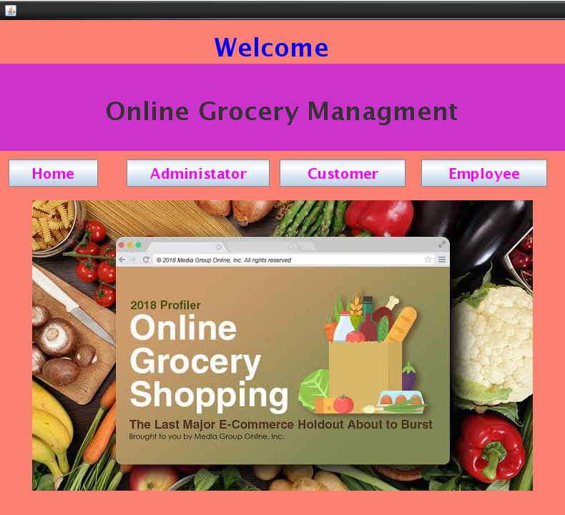

**ADMIN LOGIN:**

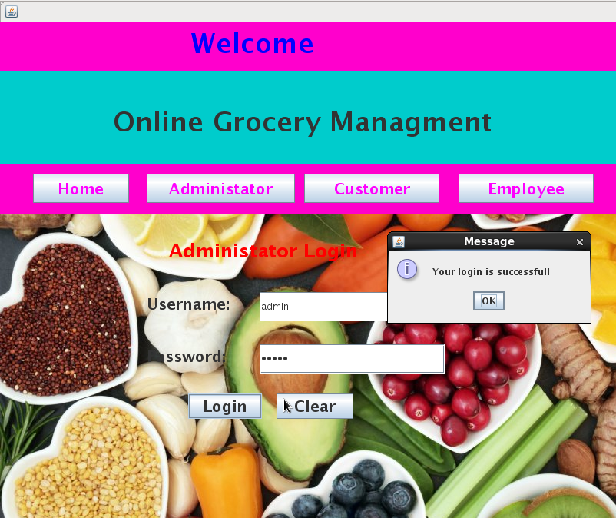

**CUSTOMER LOGIN:**

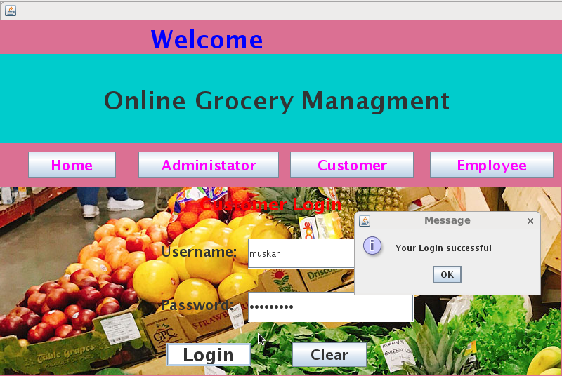

**Employee Login:**

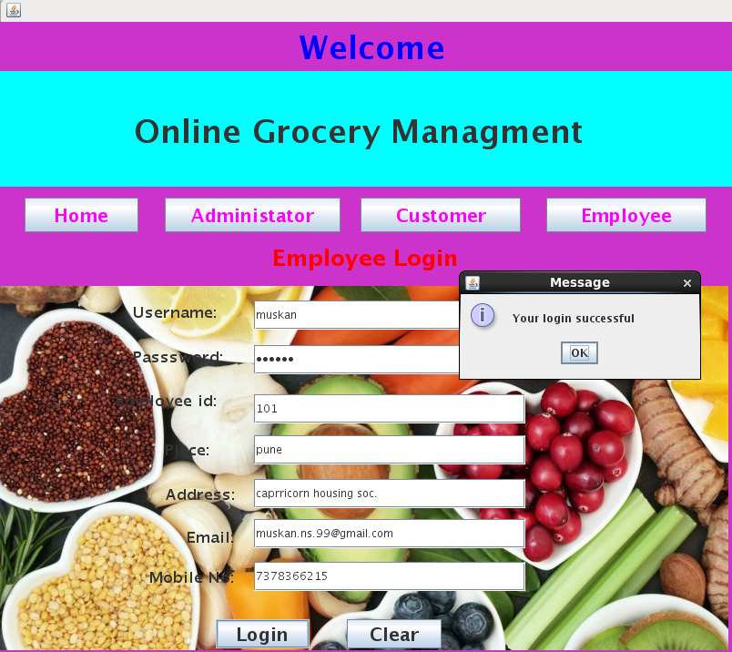

**Firstpage:**

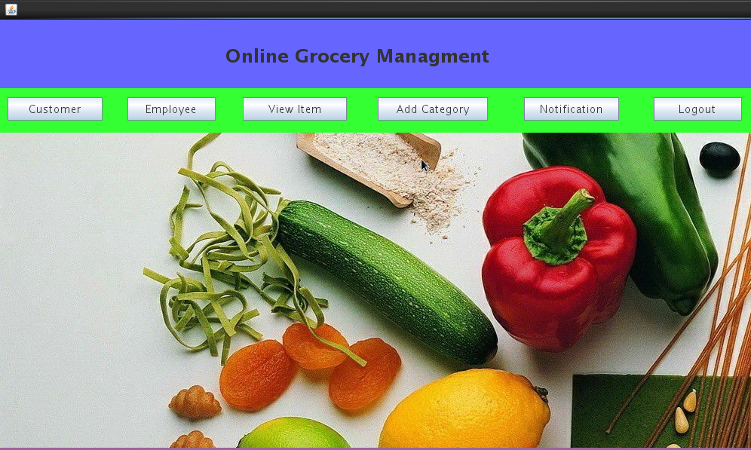

**CUSTOMER DETAILS:**

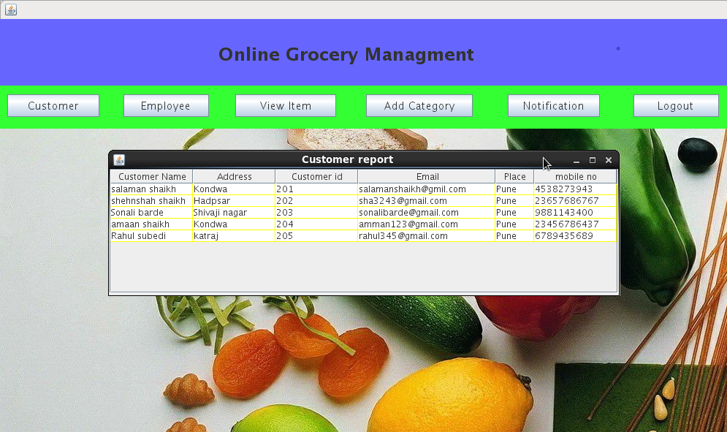

**EMPLOYEE DETAILS:**

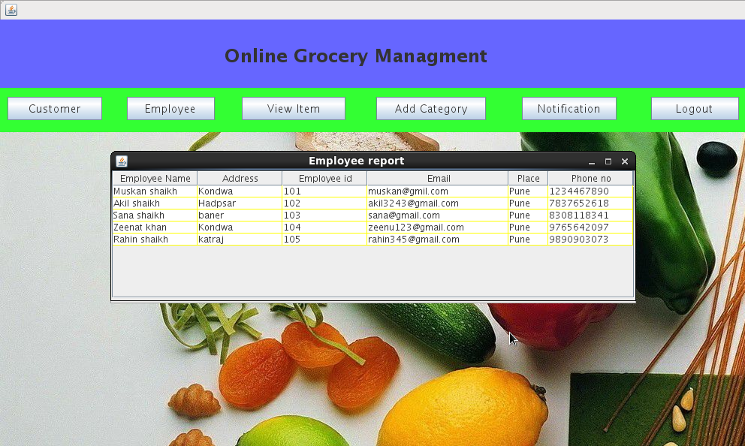

**View Item:**

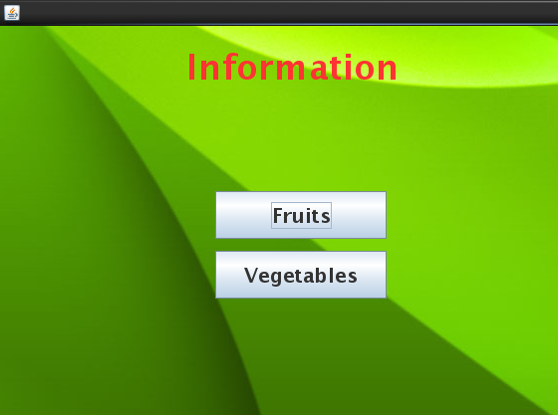

**Fruits Information:**

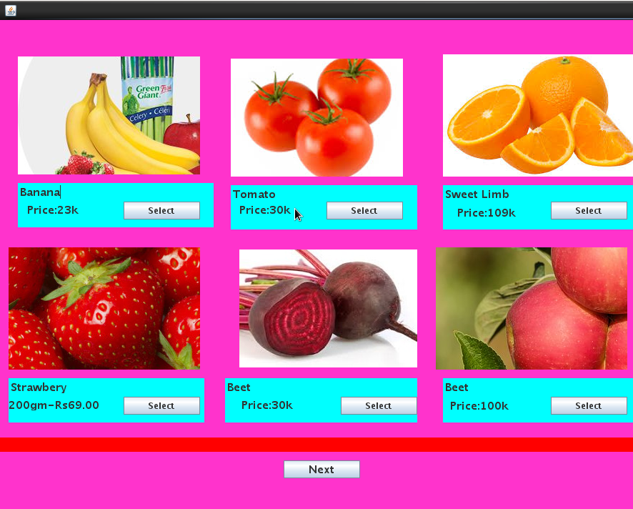

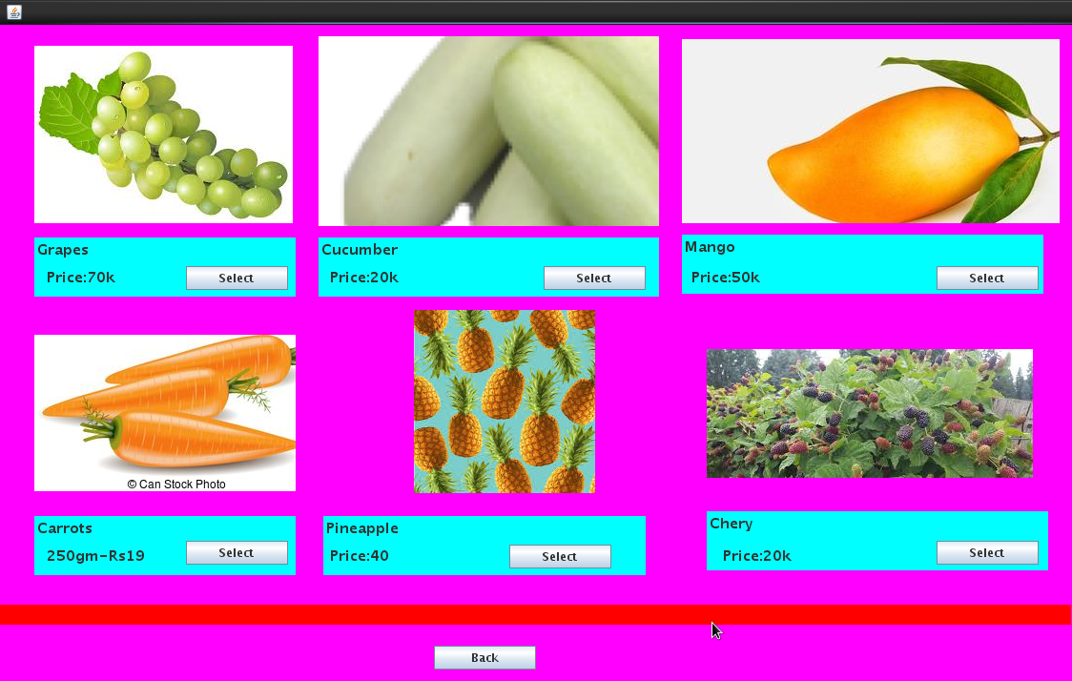

**Vegetables Information:**

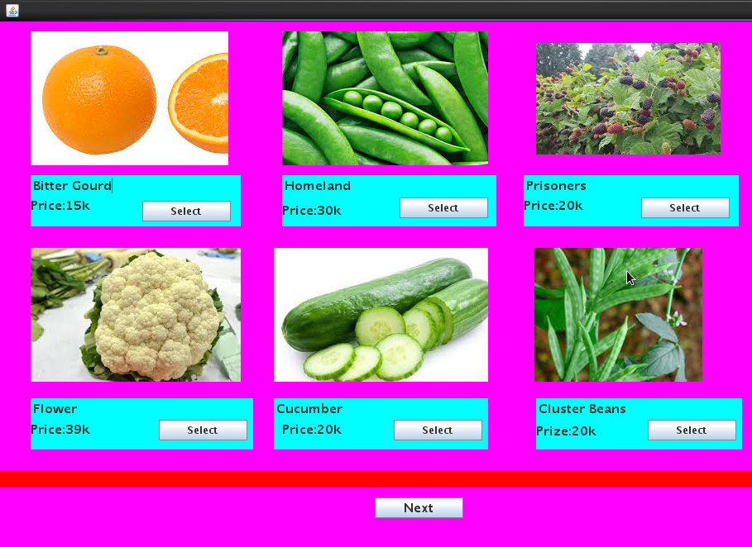

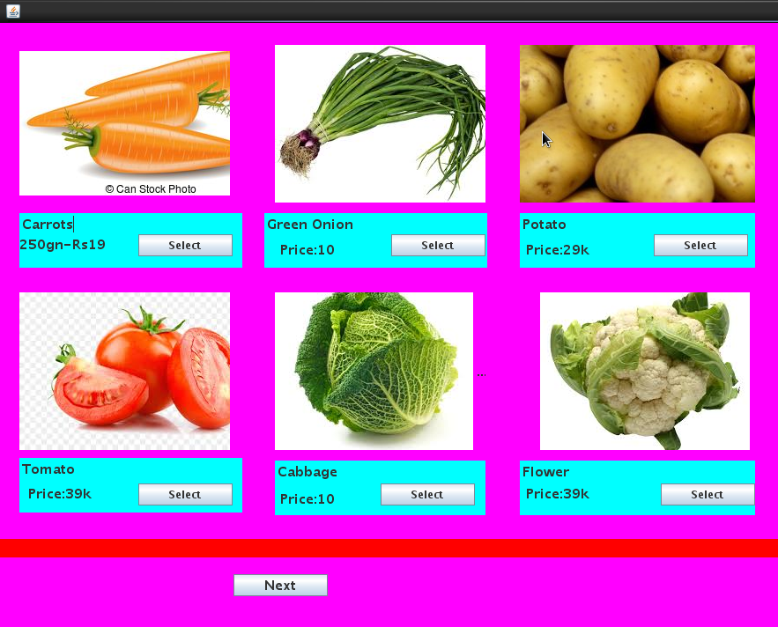

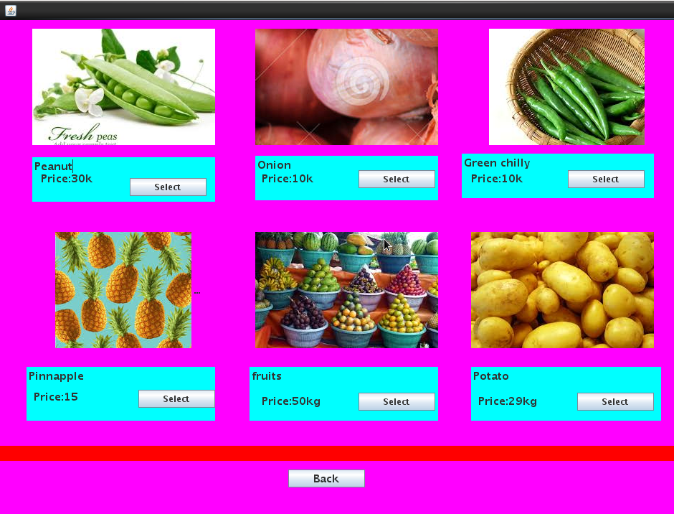

**Selected Item Information:**

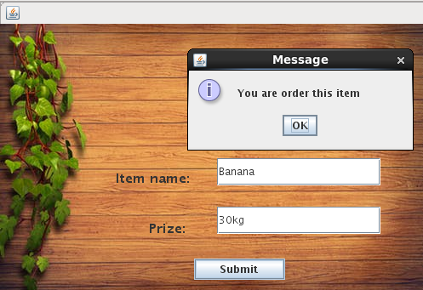

**Peraonal Information:**

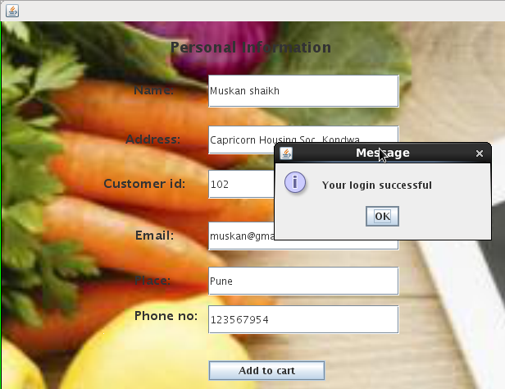

**Card Information:**

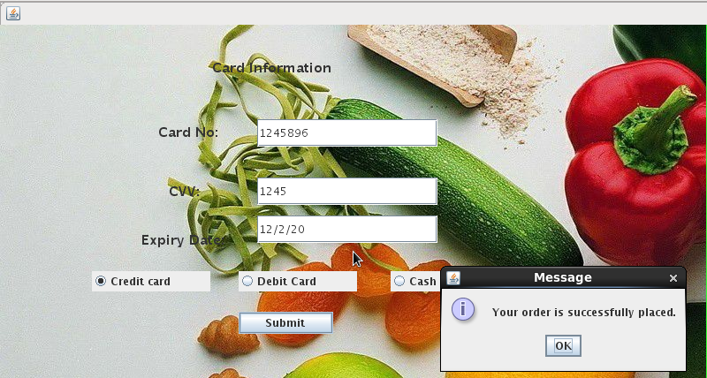

**Add Category Information:**

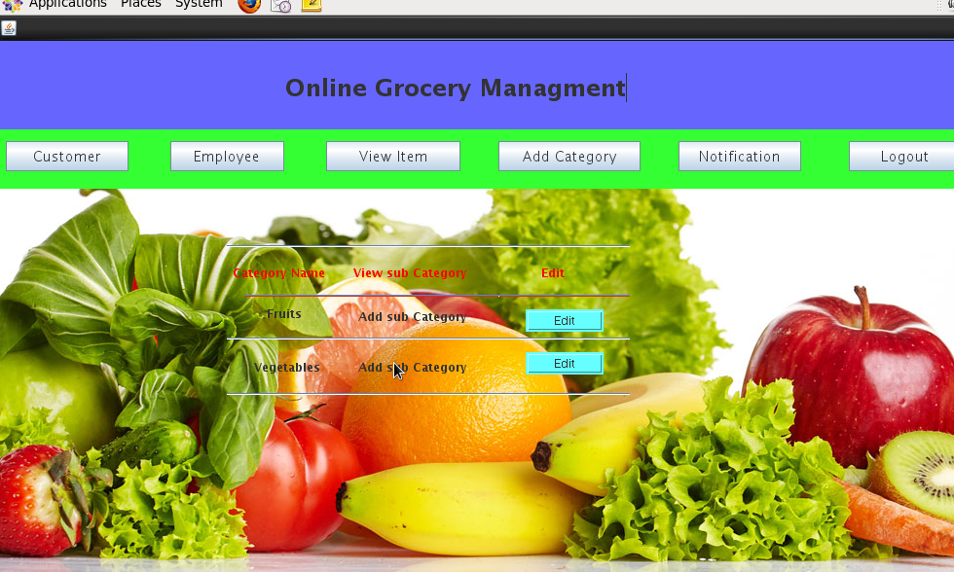

**Notification:**

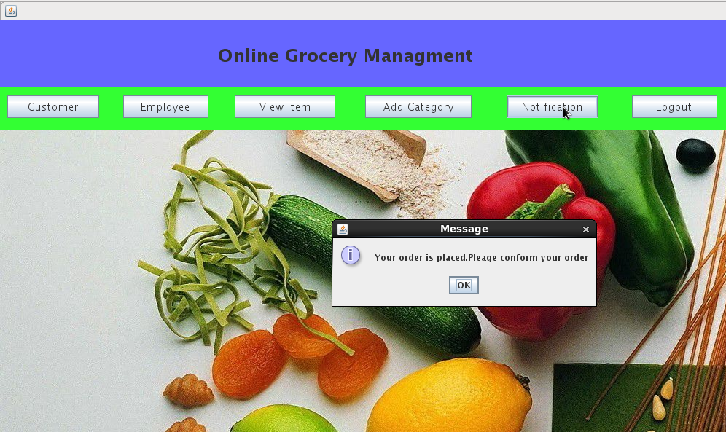

**Logout:**

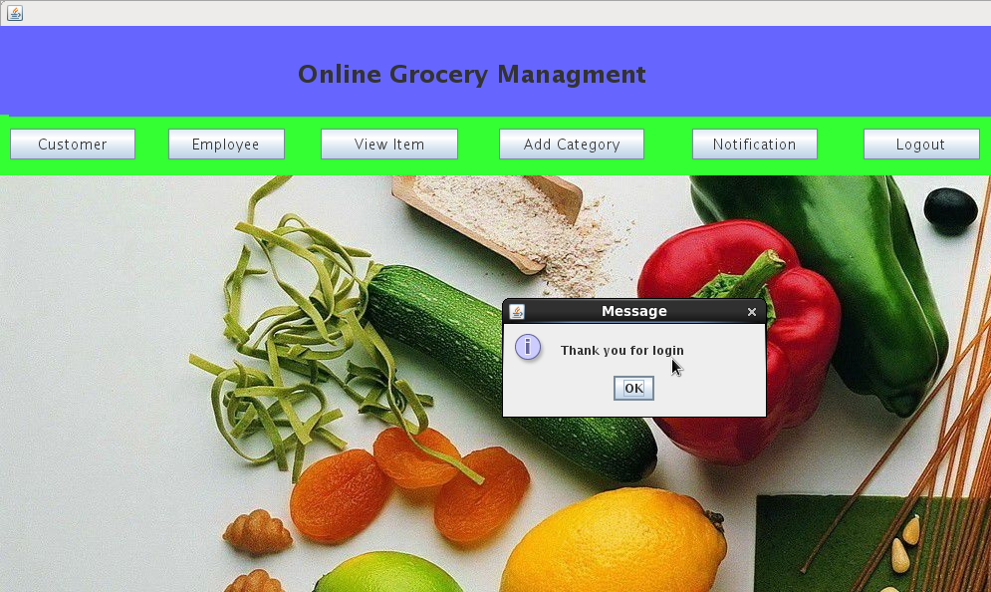

**Thanks form:**

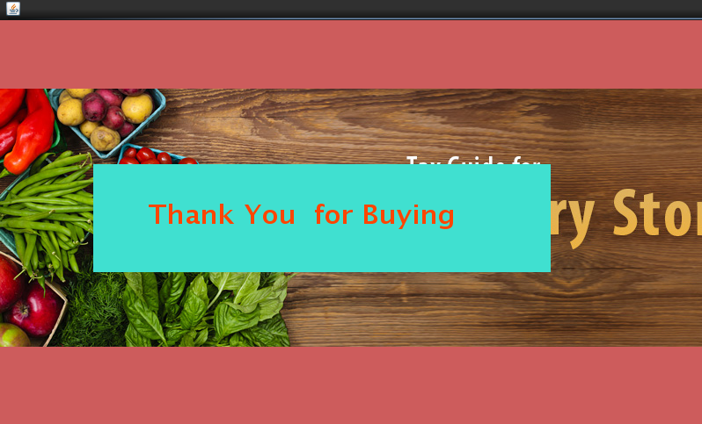

**Reports**

**Customer Report:**

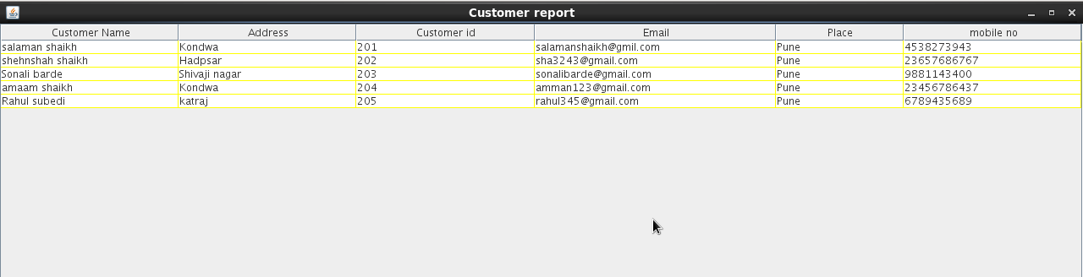

**Employee Report:**

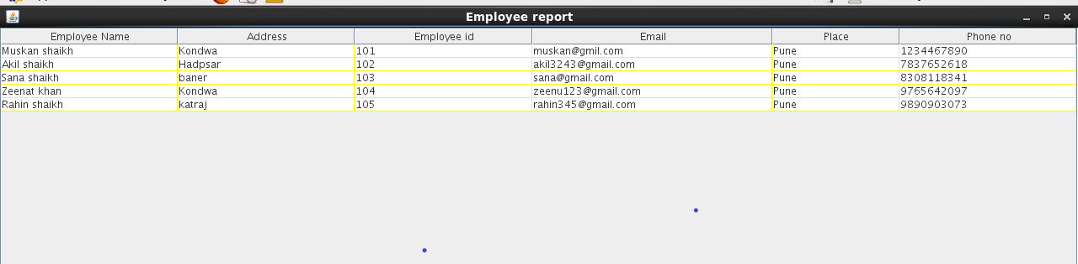

**Item Report:**

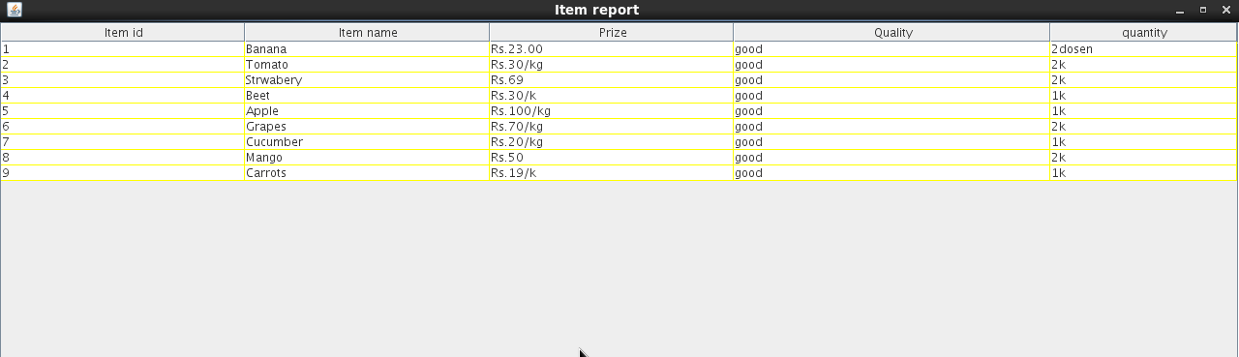

**LIMITATIONS**

* In manual system reports, documentation takes lot of time that causes daily in the processing.
* Large value of transaction of data cannot be handle efficiently.
* It is not easy to maintain records with register for long period.
* Security is not provided.
* There were many functions that demanded computerization, but there were not begin covered by the manual system.

**FUTURE ENHANCEMENT**

* We will develop our software for grocery management system.
* We will generate reports for all applicable features.
* We will make our project more users friendly.
* System record the grocery details in the systematic way.

**CONCLUSION**

* By implementing this grocery management system we are getting the more flexibility for the user.
* Which can operate from the home itself by implementing the pay and pickup and pay now options.

**BIBLIOGRAPHY:**

Books:

* Complete reference java2 by Herbert Schildt.
* Java2 Black book by Steven Holzner.
* Complete reference SQL by Groff Weinburg.
* JDBC and JAVA by George Reese.
* Unified Modelling Language user guide by Giant Dino
* [WWW.google.com](http://WWW.google.com)
* [WWW.umldiagram.org](http://WWW.umldiagram.org)